Manatee High School Band and Auxiliary 2019-2020
Application
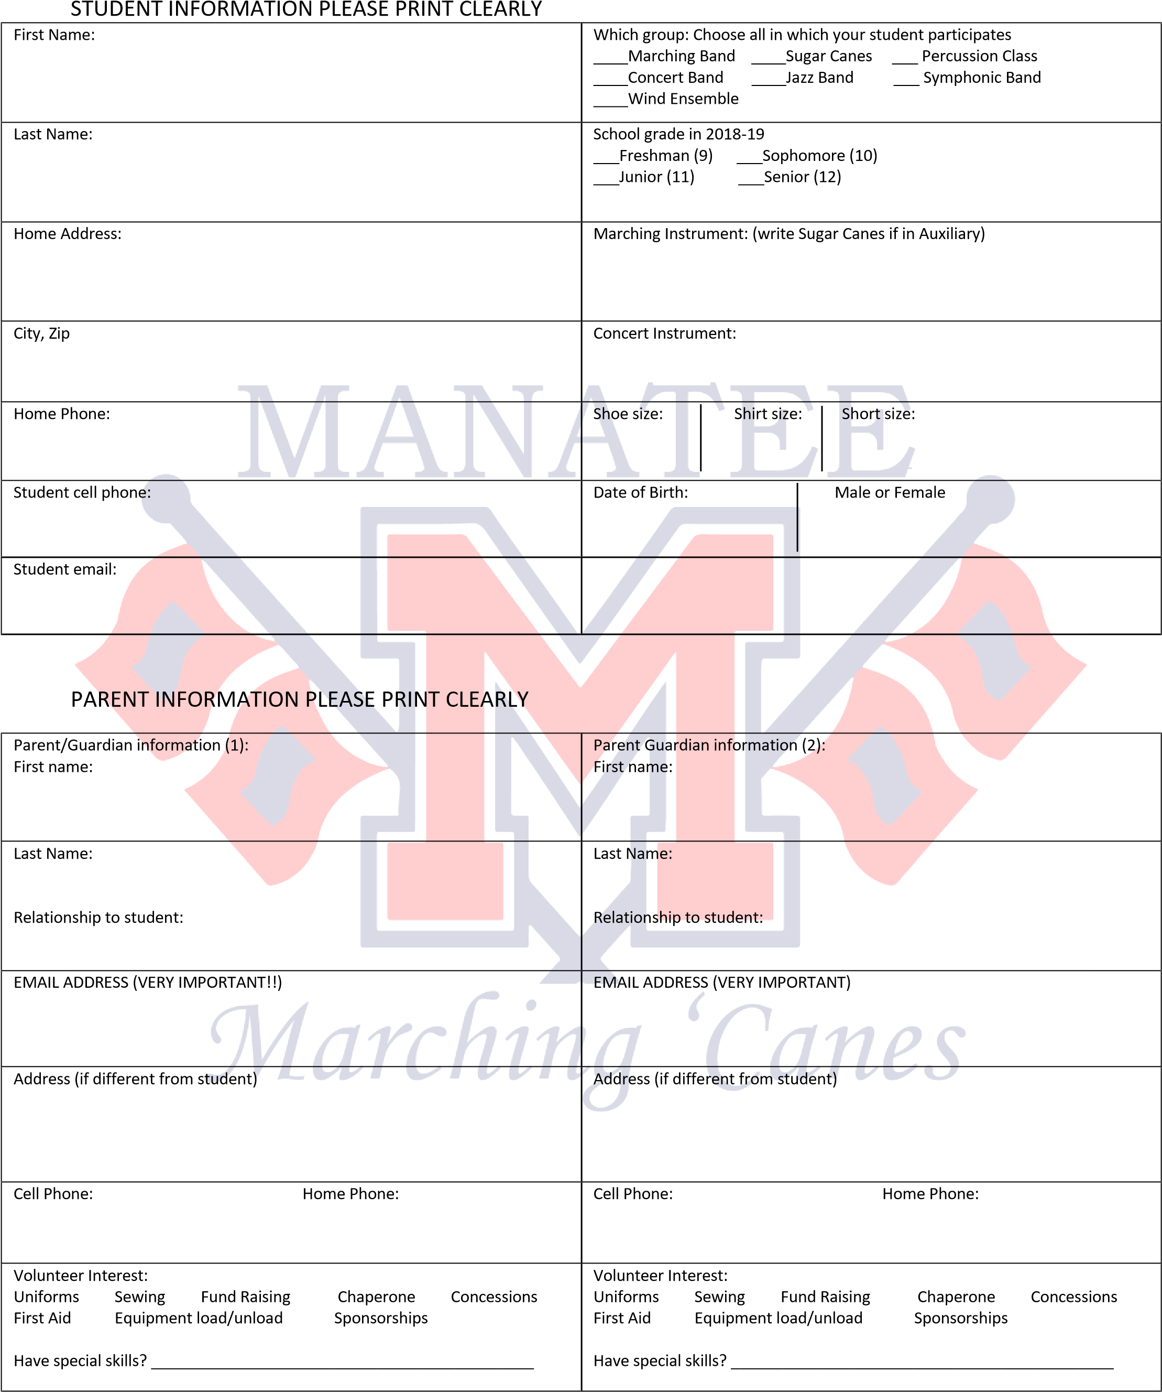

Manatee High School Band and Auxiliary
2019-2020 Fees Agreement

Registration Fee’s associated with the band are listed below:
- $375 New Member Fee (includes insurance fee)
- $325 Returning Member Fee (includes insurance fee)
Please check one of the following options and initial:
________Option 1 I understand that my student’s balance is due in a timely manner and agree to pay in full by August 13, 2019. I understand that the $50 insurance fee is due now and must be paid at Parent University. Please attach payment to this form
_________Option 2 I am requesting a Hardship/Payment plan. Please fill out the hardship request form and the payment plan request forms completely.
Initial Please the following statements after you have read and agree to the terms listed.
_________ All students must pay $50 for insurance by the end of band camp. There will be no exceptions. This will be verified before the first game of the year. Your student will not be allowed to participate if not paid.
_________ I understand that fundraising is expected and required of all band members in addition to the fees listed above in order for our band to operate to its fullest ability.
_________ I understand that my child is required to participate in ALL practices, games and events. Emergencies, illness and religious observances will be the only excused absences given. Failure to have good attendance will result in not being able to participate.
_________ I understand that my student will not be allowed to participate if my child has fees that are not paid as agreed. If my child has any unpaid fees at the end of the school year, they will be turned over to the school bookkeeper for collections. This will prevent my student from participating in school events such as prom, graduation etc., and affect eligibility to return to the program the following year until all past-due amounts have been paid. This will also impact eligibility for hardships.
Our goal is to have no student turned away from participating, so if you are experiencing a hardship please fill out a Hardship request form and turn it in immediately we will do our best to give you options to help you and your child have the best experience possible.
Please note it is the student/parent’s responsibility to make sure all fees are paid on time as agreed above. The information listed below will be used to contact you regarding fees if necessary.
Print Parent Name: | Parent Signature:
Print Student Name: | Student Signature:
Parent Email: | Parent Phone:

