Manatee High School Band Department
Trip Consent and Emergency Authorization Form (2019-2020)

Name of Student _______________________________________________________________ Birth Date __________________________ Parent/Guardian _______________________________________________________________HomePhone__________________________
Address _______________________________________________________________ Cell Phone ___________________________
_______________________________________________________________
Physician ______________________________________________________________________________________________________
Emergency Contact Person #1* ____________________________________________________________ Phone_________________________
Emergency Contact Person #2* ____________________________________________________________ Phone_________________________
Emergency Contact Person #3* ____________________________________________________________ Phone_________________________
List of Allergies _______________________________________________________________________________________________________
_______________________________________________________________________________________________________________________
List any medical conditions _______________________________________________________________________________________________
_______________________________________________________________________________________________________________________
List prescribed medications _______________________________________________________________________________________________
_______________________________________________________________________________________________________________________ Insurance Information
Company ___________________________________________________________________________ Group Number __________________
* Please put contacts in priority order so that the proper individuals will be contacted first. These contacts will be used in the event the child’s parent or guardian is unable to be reached.
Please provide on the back of this form all medical information on your child so that proper medical treatment can be given in case of illness or injury, including past operations, broken bones, allergies, seizures, sight or hearing problems, or any other special health or medical problems. In order for any medication (including all over the counter medicines) to be given, a Manatee School District Medication Authorization Form must be completed and signed by the student’s physician and turned into the school clinic. A copy must be files with this form.
Please make it your responsibility to update your child’s medical conditions and/or medications.
State of Florida, County of Manatee
I, _________________________________________________, hereby give permission to _______________________________________________
(name of parent) (name of student)
my son / daughter / ward (circle one) to attend the 2018-2019 Manatee High School Band Department activities. Should it become necessary, I hereby give permission for any necessary hospitalization, medication, and/or medical treatment to be administered to said student as the emergency situation requires.
___________________________________________ Subscribed and Sworn to before me
Parent or Legal Guardian
___________________________________________ this ___________ day of _______________________________
Address
___________________________________________ 20__________.
City / State / Zip
___________________________________________ ___________________________________________________
Telephone Notary Public (Affix Notary Seal Here)

MEDICATION AUTHORIZATION FORM

Student’s Name Sex Date of Birth Grade

School Name FAX Number

This form is to provide medical and parental authorization for medication to be provided during school hours. Both the physician and parent/legal guardian portions of this authorization form must be completed entirely, signed, and returned to the school before the medication may be administered. Over the counter medication such as Tylenol, cough syrup, Benadryl, Advil, and nutritional supplements also need this form filled out completely including the physician section.
The following section is to be completed by the prescribing physician:
The student named in this document is under my medical supervision for the diagnosis described below. I have prescribed the following medication which is necessary to be given in school. I am aware that this physician prescribed service may be administered by trained non-medical staff. NOTE: A separate form must be completed for each medication prescribed or any change.

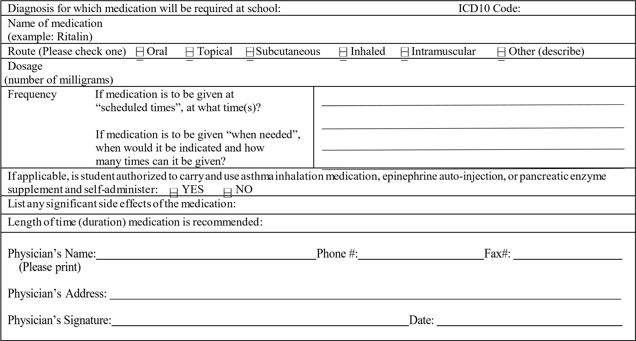

The following section is to be completed by the parent or legal guardian:

I hereby grant permission to the principal (or his/her designee) of my child’s school to administer the above prescribed medication to my child while in school and away from school while participating in official school activities (F.S. 1006.062). It is my responsibility to notify the school if and when these orders change. I understand the law provides that there shall be no liability for civil damages as a result of the administration of such medication where the person administering such medication acts as an ordinary reasonably prudent person would under the same or similar circumstances. I understand the school will not be responsible for monitoring a student’s self -medication.

Name: Relationship:
Business Phone #
Cell Phone #

Home Phone #

Signature: Parent/Legal Guardian Date:

Review/Revised: 5 /25/16

