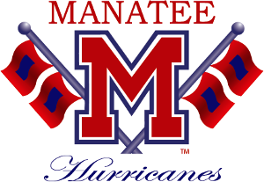

2019-2020 MHS HANDBOOK-POLICIES AND PROCEDURES AGREEMENT

PLEASE SIGN AND RETURN TO THE MHS BAND DIRECTOR

BY SIGNING BELOW, YOU ATTEST THAT:
- I HAVE READ THE 2019-2020 HANDBOOK AND AGREE TO ABIDE BY THE POLICIES AND PROCEDURES.
- I UNDERSTAND THAT THERE WILL BE FINANCIAL OBLIGATIONS TO FULFILL DURING MY TENURE IN THE MHS BAND PROGRAM.
- I WILL ONLY USE MHS BAND SOCIAL MEDIA IN ACCORDANCE WITH MHS STUDENT HANDBOOK.
- I UNDERSTAND THAT PHOTOS TAKEN OF STUDENTS DURING THE COURSE OF BAND EVENTS MAY BE POSTED TO MHS BANDS SOCIAL MEDIA SITES FOR THE SOLE PURPOSE OF PROMOTING THE BAND PROGRAM AND MANATEE HIGH SCHOOL.

STUDENT NAME (PRINTED)_________________________

STUDENT SIGNATURE_____________________________

DATE__________________

PARENT/GUARDIAN(PRINTED)_______________________

PARENT/GUARDIAN SIGNATURE_______________________

DATE___________________

